SEMESTER TWO
Papers written by Australian Maths Software

YEAR 12
MATHEMATICS SPECIALIST
UNIT 3-4, REVISION TWO
2016
Section Two
(Calculator–assumed)

Name: _________________________________

Teacher: ________________________________

TIME ALLOWED FOR THIS SECTION

Reading time before commencing work: 10 minutes
Working time for section: 100 minutes

MATERIAL REQUIRED / RECOMMENDED FOR THIS SECTION

To be provided by the candidate
Standard items: pens, pencils, pencil sharpener, highlighter, eraser, ruler.
Special items: drawing instruments, templates, notes on up to two unfolded sheet of A4 paper, and up to three calculators approved for use in the WACE examinations.

IMPORTANT NOTE TO CANDIDATES
No other items may be taken into the examination room. It is your responsibility to ensure that you do not have any unauthorised notes or other items of a non–personal nature in the examination room. If you have any unauthorised material with you, hand it to the supervisor before reading any further.

To be provided by the supervisor
Question/answer booklet for Section Two.
Formula sheet retained from Section One.
Structure of this examination

 | Number of questions available | Number of questions to be answered | Working time (minutes) | Marks available | Percentage of exam
Section One  Calculator—free | 8 | 8 | 50 | 52 | 35
Section Two  Calculator—assumed | 12 | 12 | 100 | 98 | 65
Total marks |  |  |  | 150 | 100

Instructions to candidates

1. The rules for the conduct of this examination are detailed in the Information Handbook. Sitting this examination implies that you agree to abide by these rules.

2. Write your answer in the Question/Answer booklet.

3. You must be careful to confine your responses to the specific questions asked and to
follow any instructions that are specific to a particular question.

4. Spare pages are provided at the end of this booklet. If you need to use them, indicate in the original answer space where the answer is continued i.e. give the page number.

5. Show all your working clearly. Your working should be in sufficient detail to allow your answers to be checked readily and for marks to be awarded for reasoning. Incorrect answers given without supporting reasoning cannot be allocated any marks. For any question or part question worth more than two marks, valid working or justification is required to receive full marks. If you repeat an answer to any question, ensure that you cancel the answer you do not wish to have marked.

6. It is recommended that you do not use pencil, except in diagrams.

7. The Formula Sheet is not to be handed in with your Question/Answer booklet.

9. (7 marks)
(a) Describe fully the intersection of the sphere defined by 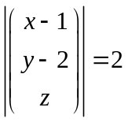 and the plane 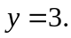 (3)

(b) Determine whether or not the two lines defined below intersect.
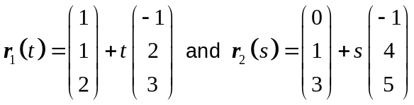 (4)

10. (10 marks)
Given ,
(a) identify the function of functions graphed below. (6)

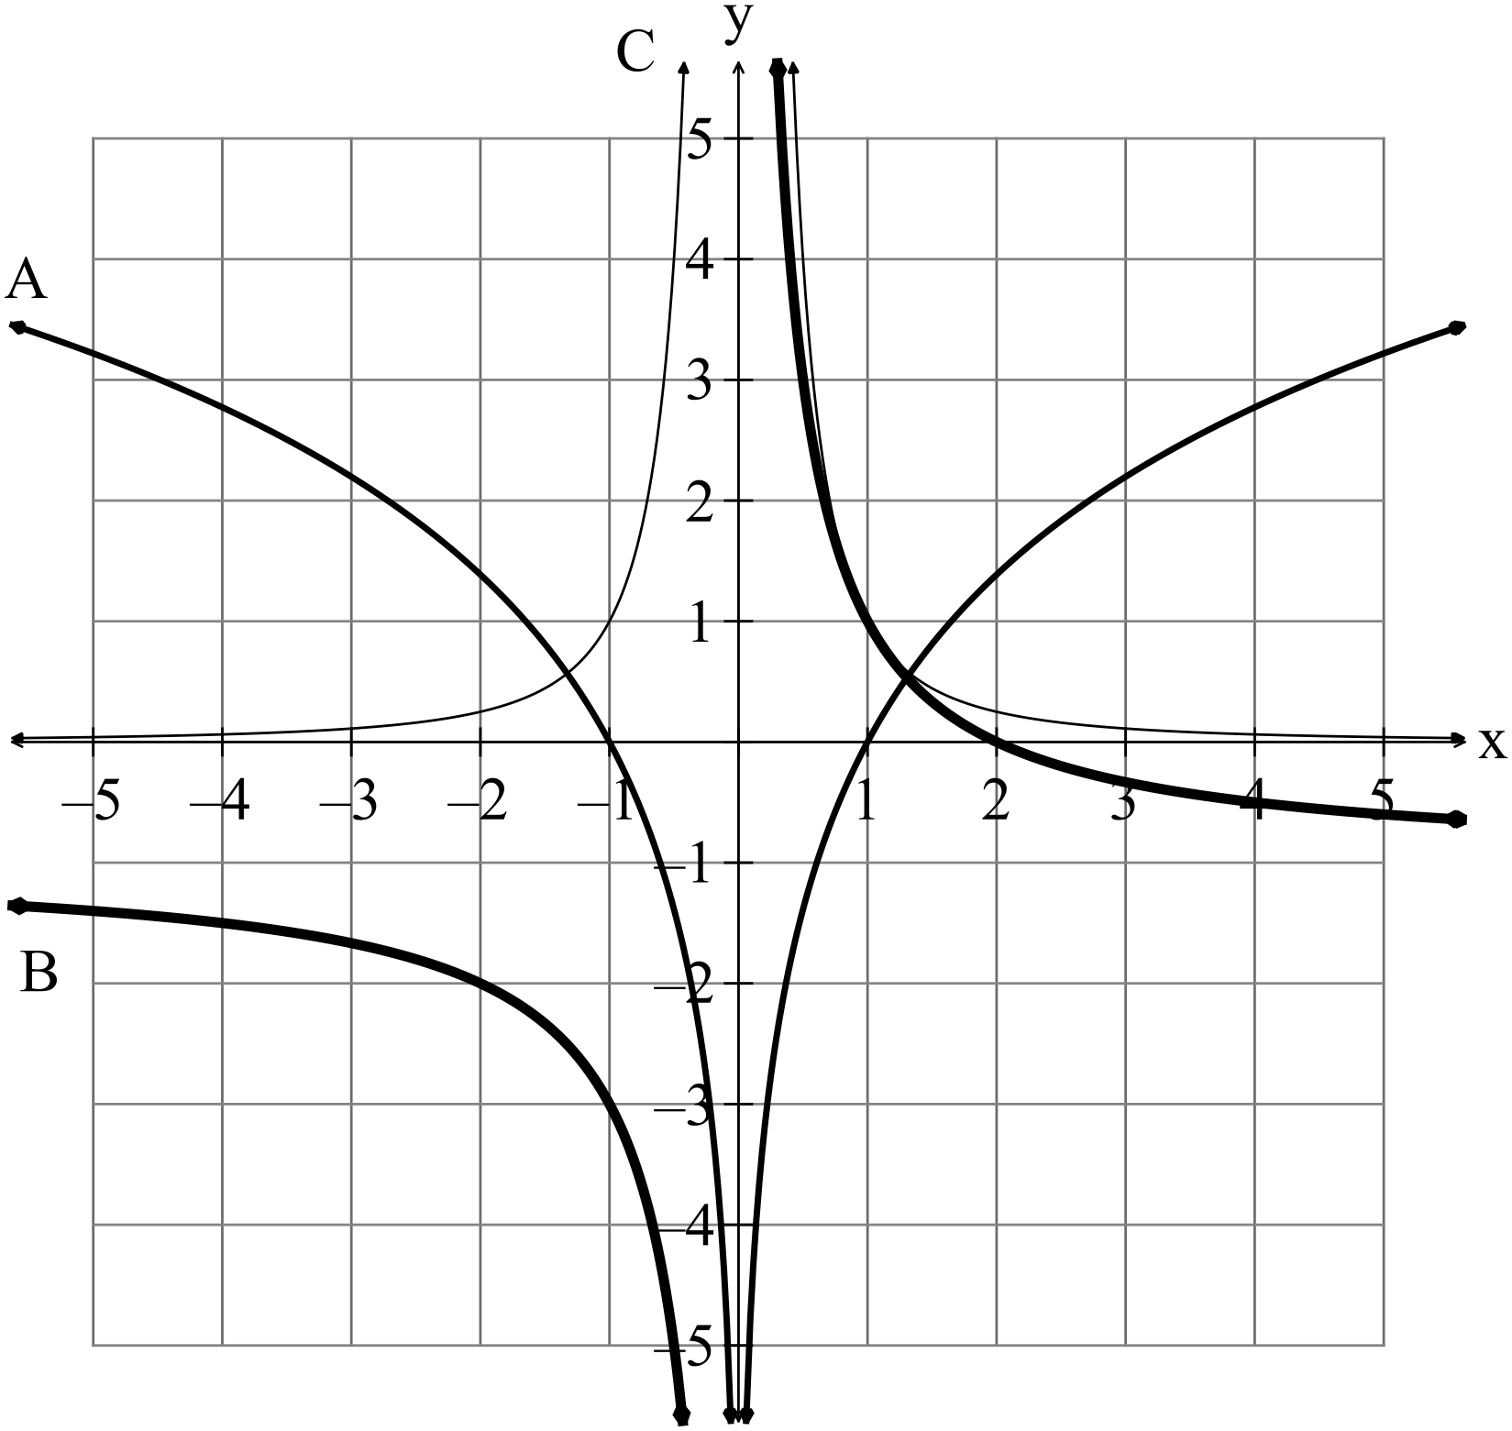

A (2)

B (2)

C (2)

(b) Find the equations of each of the graphs below given that each is one the
inverse of one the listed functions..

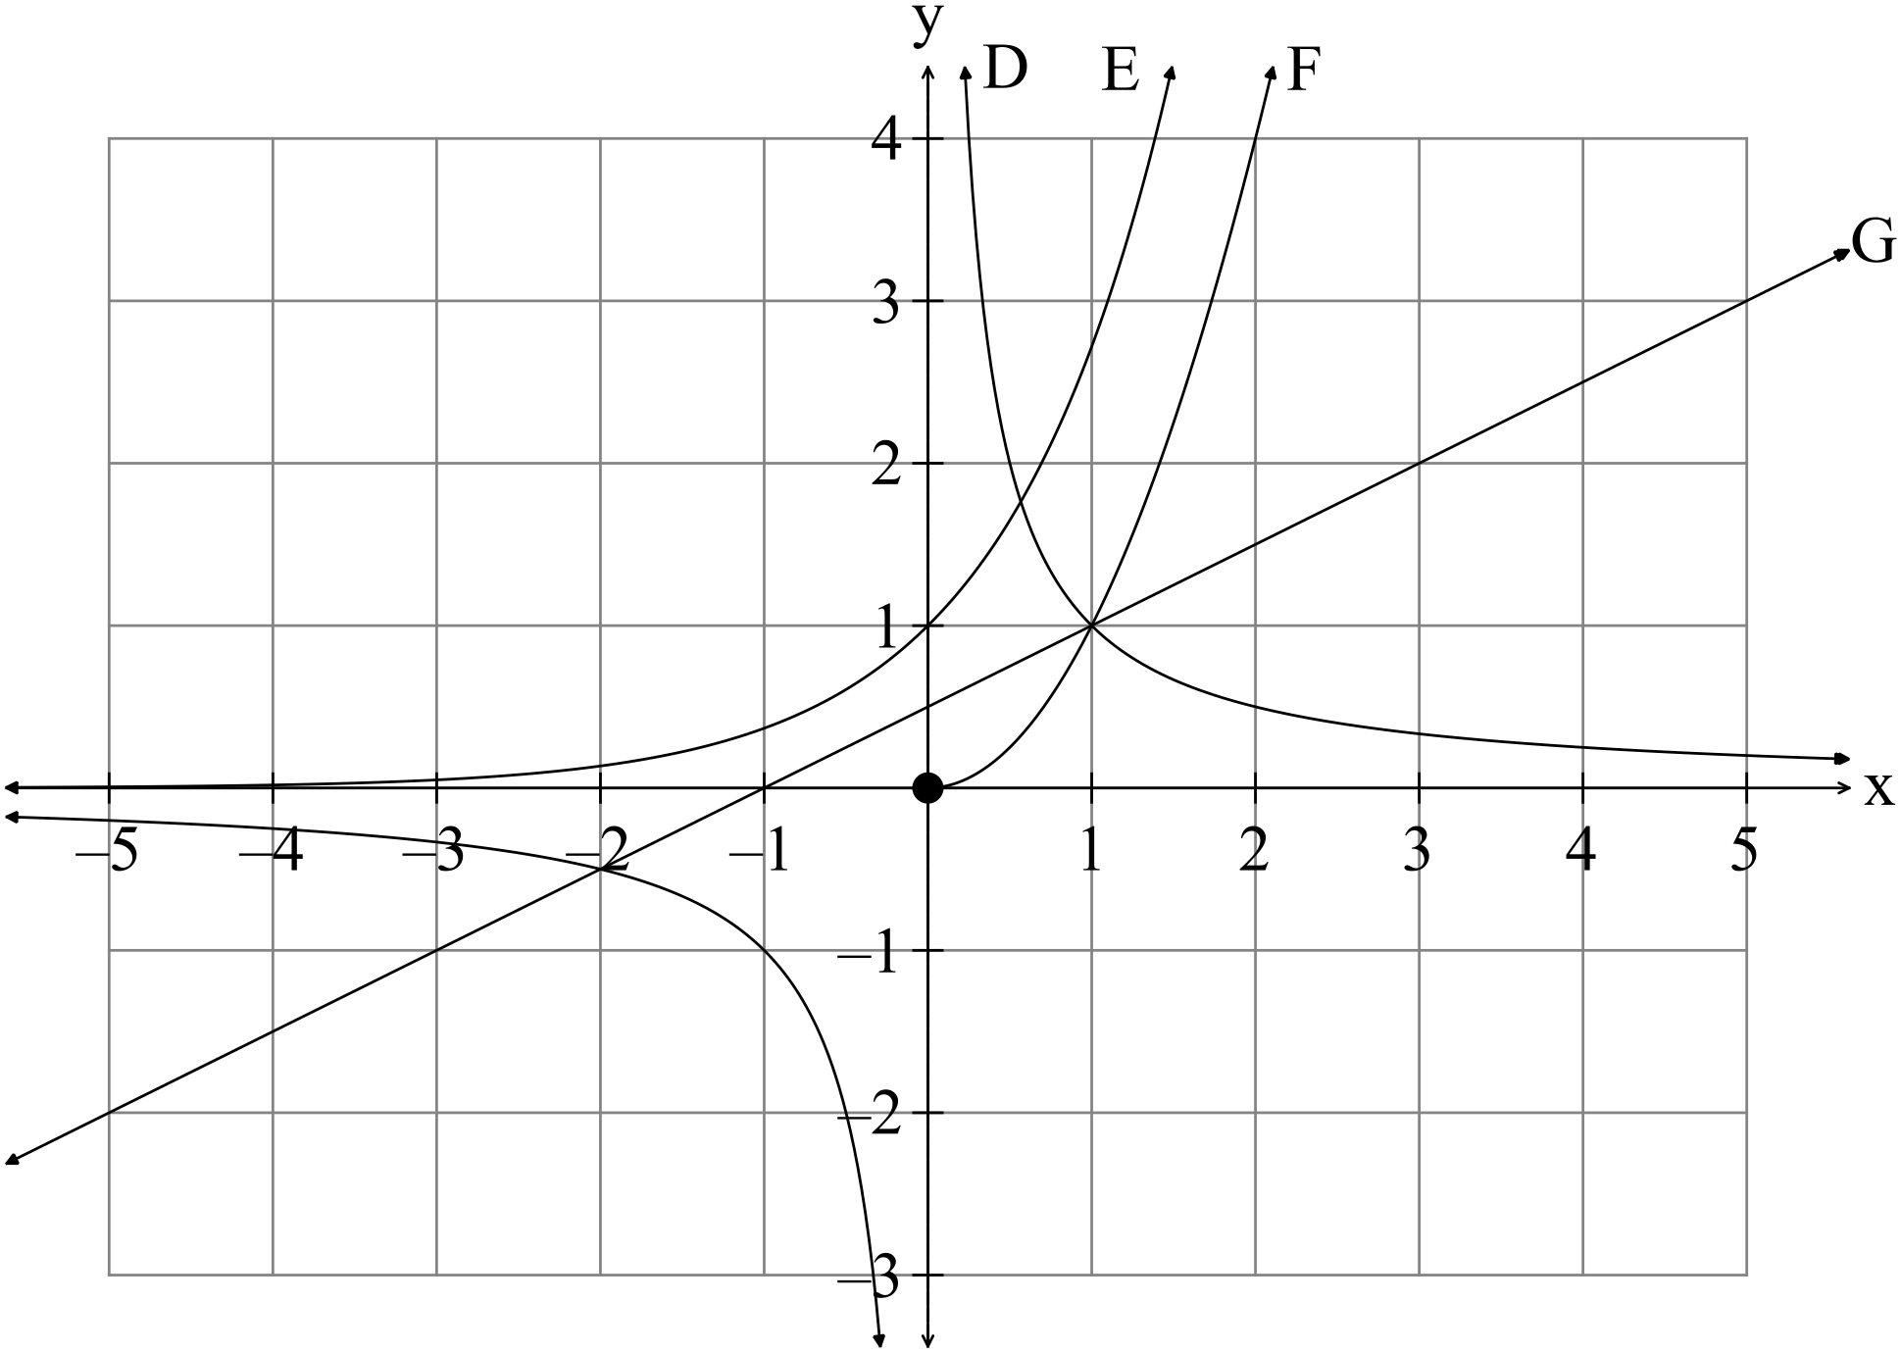

D (1)

E (1)

F (1)

G (1)

11. (7 marks)
(a) Solve the equation 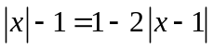 (5)

(b) The function 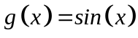 is sketched on the set of axes below.
Sketch 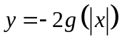 on the set of axes below. (2)
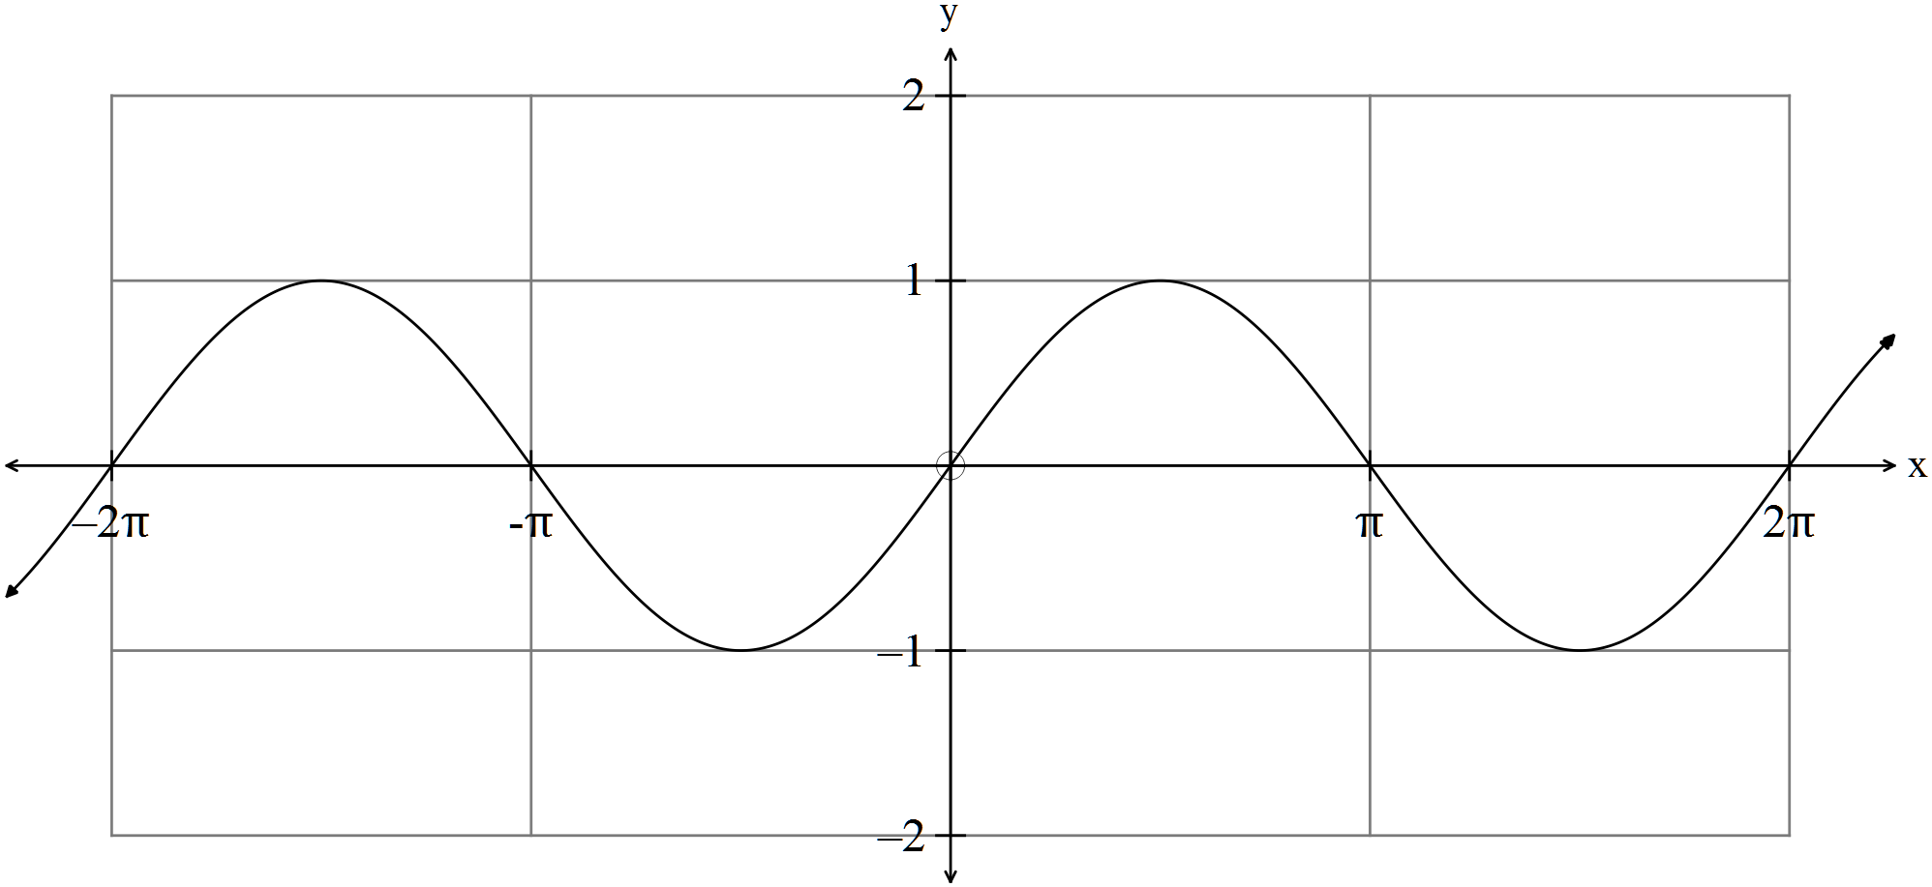
12. (8 marks)
(a) Solve 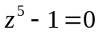 leaving your answers in 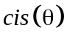form. (5)

(a) Find the area enclosed between the functions 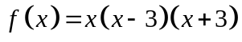 and 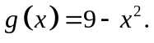 (3)

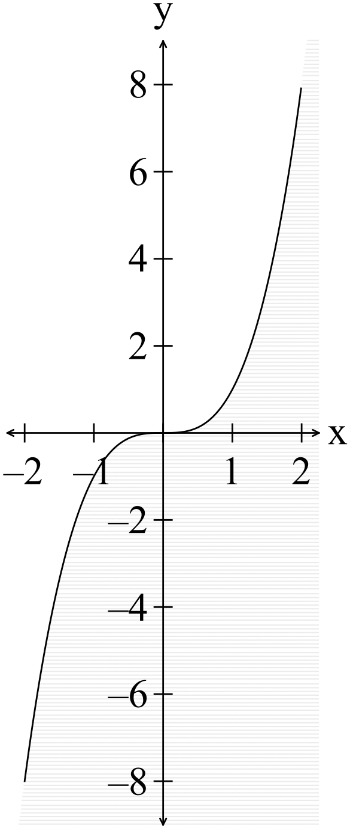13. (9 marks)
(a) Consider the function 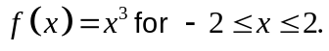
By finding the volume when the function is rotated about
(i) theaxis.
(ii) the x axis
Explain the reason for the difference in the generated
volume. (6)

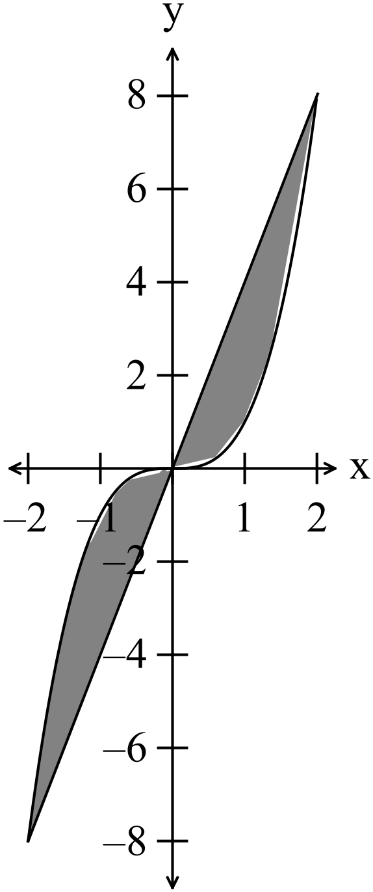 (b) Consider the two functions 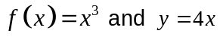
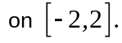
Write down the expression that needs to be calculated
To find the volume generated when the shaded area is
rotated about the axis. (3)

14. (12 marks)
(a) Given the velocity of a particle is equal to 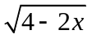 cm s⁻¹
find
(i) the acceleration when 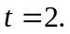 (2)

(ii) the displacement when 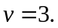 (2)

(b) Given 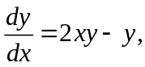 find in terms of given that the point (1, e) belongs to
the function. (4)

(c) Given the volume of a sphere is increasing at a rate of 2 cm³ per second,
find the rate of change of the radius at 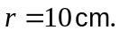. (4)

15. (7 marks)

(a) The points 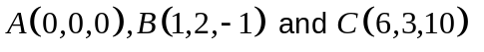 as shown in the
diagram below.

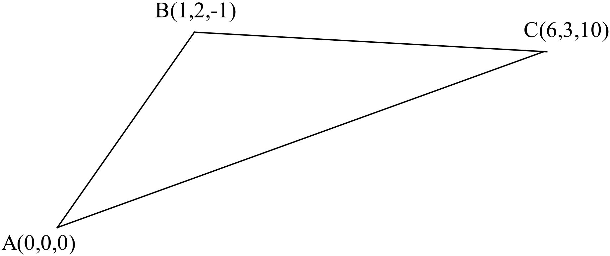

Find the vector equation of the plane ABC. (2)

(b) Given the simplified system of equations.

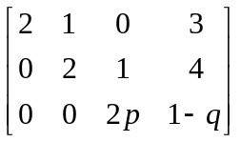

Find the values of 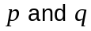if
(i) there is no solution. (2)

(ii) there are an infinite number of solutions. (2)

(iii) there is exactly one solution. (1)

16. (8 marks)

(a) Thirty samples of size 16 are taken from a population that has a mean of 15 and a standard deviation of 3.
What is the expected mean and standard deviation of the sampling distribution?
(3)

(b) A sampling distribution, formed from sets of size 40, has a variance
of 10 and a mean of 20.
.
Determine the mean and the variance of the population. (2)

(c) The mean height of 17 year old boys is 182 cm in Australia with a standard
deviation of 10 cm.
What is the probability that the average height of 9 boys selected randomly from
your class will be over 185 cm? (3)

17. (7 marks)
(a) A sample of size 100 had a mean of 10 and a standard deviation of 2.
Find the 99% confidence limits for the mean of the population. (3)

(b) Given the 95% confidence limits for the population mean are [8.5, 14.5]
Determine
(i) the mean of the population.
(ii) the standard deviation of the population.. (4)

18. (8 marks)

The number of deaths from Avian (bird) Influenza in Cambodia was reported to the
World Health Organisation (WHO).
Over the years 2010-2015 the number of deaths from Avian Influenza can be
determined by the equation 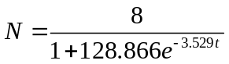 where is in years where 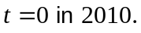

(a) Determine the number of deaths in Cambodia from Avian Influenza in 2012. (2)

(b) (i) Find the rate of increase of cases of Avian Influenza in 2015. (3)

(ii) Is the number of cases increasing or decreasing in 2013? (1)

(c) Sketch the shape of the curve (2)
19. (4 marks)
Consider the direction graph below.
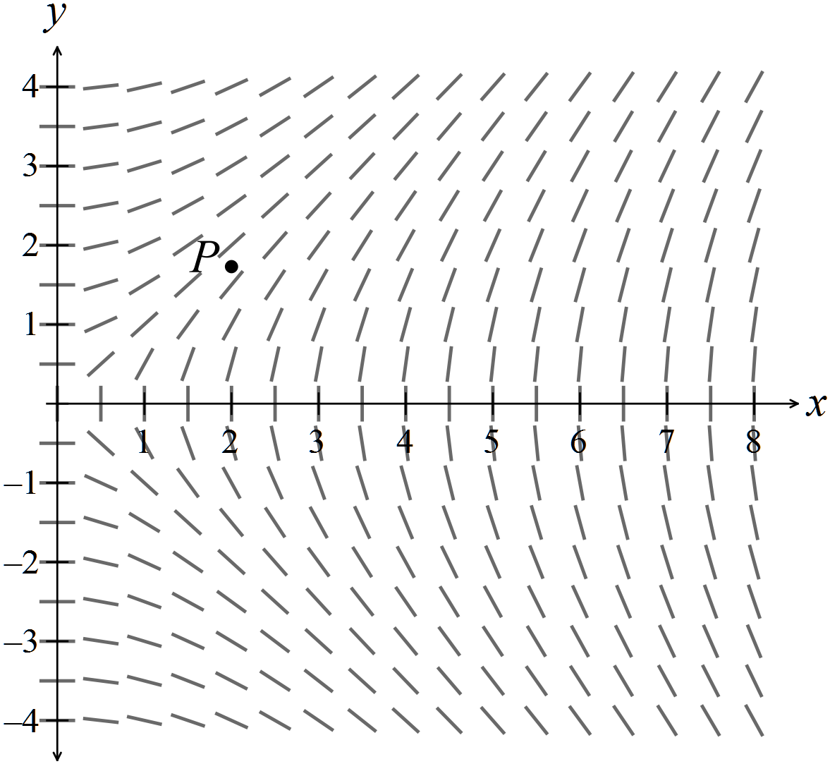
(a) Use the direction graph to help you sketch the relationship that passes
through the point 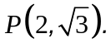 (2)

(b) Comment on the shape of the graph that passes through the point 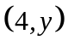
as goes from -4 to 4. (2) (2)
(1)

20. (11 marks)
(a) Simplify 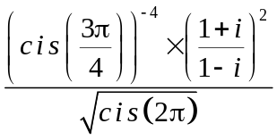 (4)
(b) Prove that
(7)

END OF SECTION TWO

